**Kol simcha torah gazette**

**For parshas Lech Lecha 5784**

Volume 8 Issue 7 (Whole #365) 13 Mar Cheshvon 5784/ October 28, 2023

**Printed L’illuy nishmas Nechama bas R’ Noach, a”h**

For a free subscription, please forward your request to [***keren18@juno.com***](mailto:keren18@juno.com)

***Past emails can be found on the website ShabbosStories.com under Brooklyn Torah Gazette***

**Caring for the Bodies of**

**1,400 Brothers and Sisters**

**By**[**Yosef Yitzchak (Tzachi) Noiman**](https://www.chabad.org/search/keyword_cdo/kid/32059/jewish/Noiman-Yosef-Yitzchak.htm)

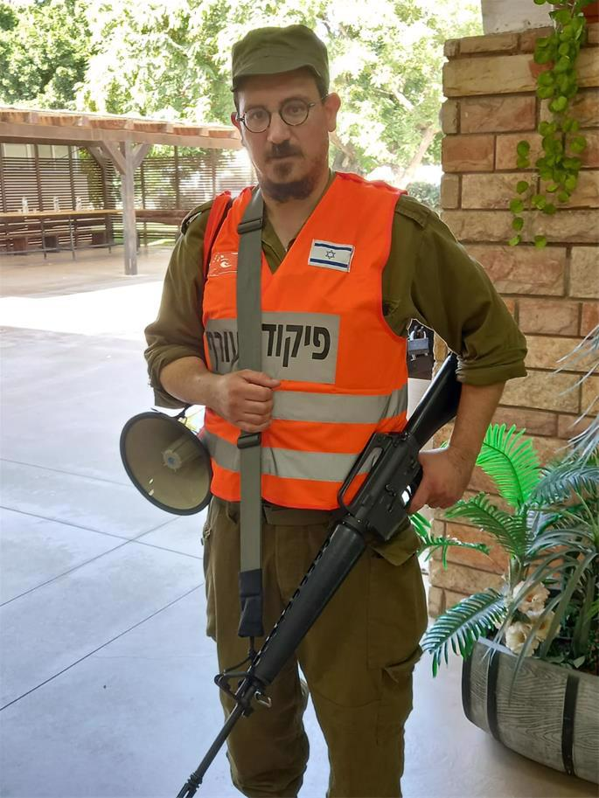

**Rabbi Noiman in uniform**

*Warning: This article contains graphic descriptions of the author’s experiences*.

I cannot get the scene out of my mind. Truck after truck of bodies. Floor to ceiling, bodies. Each one a human, a loved one, a life.

All snuffed out by hate.

As a member of Israel’s reserve army, I was called up right after the holiday. My division was asked to provide seven members to volunteer at Shura, a giant new processing center near Ramle designed to care for the bodies of victims of terror attacks and natural disasters.

It’s a big facility, but not even in their wildest nightmares did the planners envision a disaster of this scope.

I raised my hand to volunteer.

We had trained for this, of course, but always with dummies.

This was real.

I was terrified of what lay ahead.

We were prepared by mental health officers and then we set to work.

Truck after truck came rolling in, each one stacked with body bags, each bag containing another person.

**Working to Allow Families to**

**Learn the Fate of Their Loved Ones**

As we worked, we did our utmost to remain respectful and efficient, doing what we could to get the bodies ID'd as fast as possible, so families could learn the fate of their loved ones and the funerals could take place.

The bodies had been loaded onto the trucks by the heroic ZAKA volunteers, who have sadly far too much experience in the heartbreaking task of collecting bodies, blood, and limbs, ensuring that every bit of Jewish remains is given a Jewish burial.

Our first task was to assist the doctors harvesting DNA samples and fingerprints, which would be used to positively identify the victims.

They were then taken to the morgue.

Inevitably, there were also bodies of terrorists mixed in, which were placed in another area to be dealt with separately.

As one night blended into another (I was assigned to work the night shift, and the work was nonstop), I pinched myself, hoping to discover that it was all just a terrible nightmare. But my senses (sight, hearing, smell, touch, taste) all reminded me that this was real. Too real.

The bodies, of course, bore witness to the violent way in which the murders had happened. There were gunshots wounds, burns, stabbings, and more.

**Reliving a Scene from the Holocaust**

The most jarring thing was the sheer number. I felt like I was reliving a scene from the Holocaust, piles of dead Jews everywhere.

As soon as our teams identify the bodies, other teams are tasked with the excruciating duty of knocking on doors to notify their loved ones, and transferring the bodies to the *chevra kadish*a (“sacred society”) for burial.

Normally, bodies are bathed and clothed in white linen for burial. But in this case, when they were killed just because they were Jews, they are buried exactly as they were found, in their bloody garments.

It is not for us to wash away what has happened. That is for G‑d Himself to do.

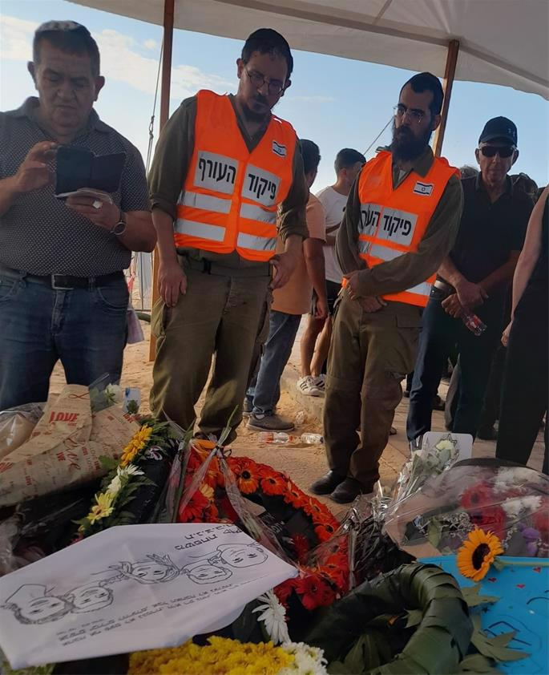

**Rabbi Noiman at the funeral of the Kutz family**

The work of caring for the dead is called *chessed shel emet*, “true kindness,” in the sense that we know the recipient cannot return the favor. Unlike anything we

do for living people, from whom we may expect something in return, the kindness we do with the dead is “true” kindness.

This week I felt that there is also an opposite meaning: These holy souls who made the ultimate sacrifice for being Jews here in the Land of Israel did *me*a true kindness when I was privileged to assist in taking care of them and bringing them to a Jewish burial.

I felt—in the most raw and concrete way—how we are all one, united by blood and the covenant [G‑d](https://www.chabad.org/library/article_cdo/aid/433240/jewish/God.htm) made with our ancestors. Political parties, societal differences, levels of education—none of it matters here.

**We are all Jews.**

And we are all in it together.

We stood shoulder to shoulder. Me and my comrades from Battalion 926 of the Home Front Command: Shira the doctor who took DNA samples and fingerprints, Omri from the police, the angels of ZAKA, Julia from the Ministry of Health, and Shlomo from the *chevra kadisha*. The full spectrum of the Jewish family.

There was one especially painful moment when we treated five casualties in a row and realized that they all belonged to a single family from Kfar Aza, who had been murdered together in their home.

Yesterday, we were called to assist with conducting a funeral in Gan Yavne. Not one funeral, but five. And yes, it was the Kutz family from Kfar Aza, may G‑d avenge their blood.

Every person is a whole world, and yesterday I witnessed the closing of a chilling circle for five worlds: Aviv the father, Livnat the mother, and the three children Rotem, Yonatan and Yiftach. The funeral was indescribably painful; the eulogies portrayed a warm and loving family, people of values, good-hearted, “salt of the earth.”

As I wiped away tears and gritted my teeth, I felt more strongly than ever that now is the time for us to work together — as we have been — to build each other up, to heal the broken-hearted, to be good to each other, to instill hope, faith and confidence in G‑d and His people.

We are like Noah after the flood, surrounded by devastation but ready to rebuild, confident in G‑d’s assurance of a brighter future. May it be now with the coming of Moshiach.

Am Yisrael Chai!

*Reprinted from the current website of Chabad.Org*

**Thoughts for Our Parsha**

And the land was not able to bear them that they might live together; for their possessions were great, and they could not live together (Gen. 13:6)

It was not poverty but prosperity that drove Lot and Abram apart and destroyed their peace. In fact, most antagonism and dissention between people can be directly attributed to wealth - i.e., from being jealous of someone who has more of it... *(Ohr HaTorah)*

And he believed in G-d, and he counted it to him for righteousness (Gen. 15:6)

Not only did Abraham believe in G-d, but he was appreciative of G-d's kindness and generosity in giving him the intelligence to have faith. *(Avodat Yisrael)*

**Rav Avigdor Miller on What Do We Answer About the Rifts That NASA Found on Mars?**

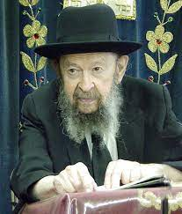

This question reminds me of a question once asked here by a timid little boy; he thought he was going to turn the world upside down. He said, “What do we answer to the question of the dinosaurs?!”

So, I told him, “We don’t answer anything. What do you answer to the giraffes?”

What is the difference between a dinosaur and a giraffe? There are plenty of animals that went extinct. So, the dinosaurs also went extinct. “Oh, but the fossils; they’re so old!”

Who said fossils are old? Don’t you know that we have found fossils of modern men, fossils as recent as 300 years old. I explained here already once that in the Museum of Natural History in London, you have a fossil of a Guadalupe Indian that’s no more than 300 years old. Fossils are not old; it’s only because evolutionists need great time periods – otherwise how could such a fantasy be realized that from a germ should develop a man? – you must have untold eons of time for it to happen. So, because they needed so much time, they manufactured a theory of time.

But there isn’t the slightest indication anywhere that there was such time. And therefore, in Noach’s time, before the Mabul, there certainly were dinosaurs and probably none of them survived the Mabul. And so, a dinosaur is just as significant to us as the passenger pigeon which also went into extinction.

Now, what do we say to the rifts on Mars? What do you say to the rifts in the Sahara Desert? Whatever you’ll say there, you’ll say here. It could be that the rifts in the Sahara Desert were created in the beginning of the world – Hakadosh Baruch Hu didn’t make the world as smooth as a billiard ball; He certainly made the world with ups and downs, with hollows and with mountains and so on.

It’s necessary for the control of climate and for various other reasons. So, the same thing on Mars; Hakadosh Baruch Hu made rifts on Mars. And if you’ll say the rift in the Sahara Desert came after Creation by means of some upheaval so there was an upheaval on Mars too. So, what’s the problem?

Just because someone says “Boo!” without any explanation at all, immediately the person who has no emunah is frightened out of his wits. Say “Boo!” back to him!

*Reprinted from the Parshas Noach 5784 email of Toras Avigdor based on Tape #60 (April 1974).*

**How Could Lot Have Abandoned G-d?**

Lot journeyed from kedem / the east (13:11) Rashi comments: He journeyed away from the Kadmon / the One Who Preceded everything. R' Yosef Leib Bloch z"l (Rosh Yeshiva of Telshe; died 1929) writes:

The story of Lot demonstrates that it is not enough to know that there is a Creator and that He is actively involved with His world. The Sages teach that Lot was accustomed to seeing angels in Avraham's house.

Nevertheless, he readily chose to leave Avraham and to live among the evil-doers of Sdom. How did this happen? It happened because a person who does not actively work on character refinement will forever remain enslaved to his human nature, the side of him which sees the wealth of Sdom but not its evil.

This explains, as well, why the generation of the Exodus stumbled repeatedly. They attained a knowledge of G-d and His Power that no generation before or since has attained. Nevertheless, unless one actively works on character refinement, all of his abstract knowledge will not save him. (Shiurei Da'at)

*Reprinted from the Parshat Lech Lecha 5784 email of R’ Yedidye Hirtenfeld’s whY I Matter parsha sheet for the Young Israel of Midwood in Brooklyn, NY.*

**Understanding the Significance of the**

**“Sparks of Holiness”**

**From the Teachings of the Lubavitcher Rebbe**

**Rabbi Menachem Mendel Schneerson, Zt”l**



In the Torah portion of Lech Lecha, we read about the "Brit Bein Habetarim - the Covenant of the Pieces," that G-d made with our forefather Abraham. It was then that G-d promised to give Abraham the land of Israel as an inheritance for his descendants forever.

Among the many things G-d told Abraham was that his children would one day be exiled in Egypt. However, G-d promised that their exile would end. Not only would they return from their exile but "afterwards they will go out with great wealth."

The intent of G-d's promise of "great wealth" was not simply as payment for their suffering. In truth, G-d's statement that "afterwards they will go out with great wealth" revealed the entire purpose behind their descent into Egypt.

At first glance this is difficult to understand. Had G-d asked the Jewish people to relinquish the "great wealth" they were promised in order to hasten the end of their suffering they would have surely agreed. Nonetheless, we find that G-d did not offer them this choice, as the "great wealth" they were to obtain in Egypt was of particular significance.

What was this "great wealth" that required the Jewish people to endure a bitter exile for hundreds of years, and why was it so important?

The inner purpose of the Jews' descent into Egypt was that through their service of G-d, the "sparks of holiness" that that country contained would be refined and elevated. Indeed, the Jews' Divine service was successful, as it states, "And a mixed multitude (erev rav) also went up with them," for the numerical equivalent of "rav" is 202 - i.e., all 202 sparks of holiness that Egypt possessed were successfully purified.

This, then, is the "great wealth" that the Jews brought out of Egypt with them. Indeed, it was for the Jewish people's own benefit; had it not occurred, Abraham would have had a valid complaint to level against G-d.

But what was the benefit that they derived?

Every soul has its own unique role in the mystical process of "elevating the sparks." By purifying the specific "sparks" he encounters throughout his life, the Jew brings redemption to his own soul, and to the world at large.

The lesson to be derived from all this is that the Jew's function is to involve himself in the material world for the express purpose of elevating these hidden sparks of holiness. For with these sparks, we will merit to greet Moshiach imminently.

*Reprinted from the Parshat Lech Lecha 5761/2000 edition of L’Chaim. Adapted from Volume 3 of Likutei Sichot.*

**The Need to “Go Out”**

And the L-rd said to Abram, go out from your country, and from your family, and from your father's house (Gen. 12:1)

There are some lands that produce naturally strong and robust people, but as G-d implied to Abraham, a Jew mustn't rely on his inborn strength. Nor should he content himself with the positive character attributes he inherited from his family, or with the fact that his father was holy and righteous. Rather, every Jew must "go out" and expend his own efforts, as it states in Psalms (128:2), "For you shall eat the labor of your hands; happy shall you be, and it shall be well with you." *(Daat Moshe)*

*Reprinted from the Parshat Lech Lecha 5761/2000 edition of L’Chaim.*

**The Writing is on the**

**Wall for Jewish Students**

**We must challenge professors and students who tacitly endorse antisemitic violence in the guise of ‘resistance’**

**By Thomas Ullman**

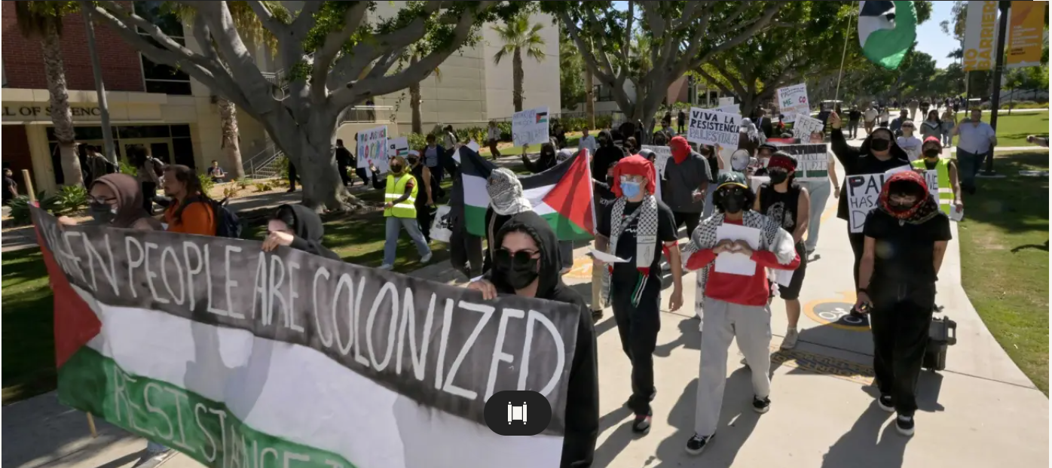

Today, to be a Jewish [college] student is to be alone. In the wake of Hamas’ devastating attack on Israel in which it brutally massacred over 1,000 Israeli civilians, American universities have proven to be treacherous environments for Jews. Our peers now extol the would-be genocidaires, both in online posts and on stick-mounted signs. We are forced to watch as mobs of students demand the destruction of our homeland.

What has been often overlooked by observers of these events, however, is the culpability of the universities themselves. The antisemitism of my classmates did not develop in a vacuum. It is the result of obfuscations by our professors, many of whom have portrayed Hamas as merely a “resistance group,” as well as the refusal of our universities to denounce the terror.

I have had the displeasure of seeing this unfold firsthand. As a Jew and university student in Washington, D.C., I watched as thousands marched in support of the “martyred militants” of Hamas, an organization whose charter [explicitly calls for the genocide of Jewry](https://www.theatlantic.com/international/archive/2014/08/what-would-hamas-do-if-it-could-do-whatever-it-wanted/375545/). Dispersed among the crowds were many of my classmates, people whom I once felt I could trust. They shared lunches with me, worked on projects with me, and shared textbooks with me.

**Jewish Students Urged to Stay Home and Miss Classes**

Now, they celebrate the deaths of people like me. The agitation came to a head last Friday, when a former Hamas leader [called for an international “day of rage,”](https://www.washingtonpost.com/dc-md-va/2023/10/12/dc-hamas-day-rage-protests-friday/) with the purpose being to extend the reach of the group’s attack to the diaspora. [Jewish organizations urged Jewish students](https://jewishinsider.com/2023/10/hamas-day-of-rage-jewish-schools-synagogues-u-s/) to stay home and miss class. I hesitantly did so.

As long as American colleges continue to tacitly endorse calls for antisemitic violence, I will continue to earnestly write in defense of the Jewish student.

I emerged from my involuntary hiding the next morning and headed for one of the dining halls. I walked warily; every passerby could have been part of the flocks that defended the attacks. On my way there, I crossed paths with a close friend of mine. A student with a fervid interest in progressive politics, he was as compassionate a figure as one could be. I felt the tension immediately evaporate as he approached me with an outstretched hand.

Our conversation began with typical niceties, but my heart sank when he told me that he was on his way to a demonstration. I dared not inquire further. I didn’t want to know that he had joined ranks with the bloodthirsty marchers, but he nonetheless found a way to force that fact into the conversation. “I’m glad to see so many people standing up to barbarism and colonialism,” he said at one point, pointing to an anti-Zionist flyer pasted onto a nearby lamppost.

**Dismissed by a Sneering Remark – “…You’re a Jew”**

I pushed back gently, remarking that child murder wasn’t exactly “standing up to barbarism.” He appeared nonplussed. “Isn’t it rather hard for the Jews,” I asked, “to colonize the land from which they originated?” He stood unspeaking for a moment, as if he were reassessing our friendship. He sneered: “Of course you’d say that. You’re a Jew.”

I walked away from our encounter disoriented. This was an individual who was avowedly “anti-racist.” Hearing antisemitism come out of the mouth of a progressive friend left me dejected. After I returned to my room, I found the same vitriol on social media. Most of my peers had posted some sort of defense of Hamas’ actions, blaming the victim by accusing Israel of igniting this horror.

Various student organizations released similar statements online. One popular post from a pro-Palestine student group stated that it “[reject[s] the distinction](https://www.theatlantic.com/ideas/archive/2023/10/college-students-justice-for-palestine-chapters-hamas/675640/)” between civilians and soldiers of the Jewish state. The “decolonial” impetus for the incursion, said the group, was not meant to remain “an abstract academic theory to be discussed and debated … [it was meant to be] a tangible, material event.” That event turned out to be a pogrom.

The likes on that post numbered nearly 1,000, equivalent to roughly 1 out of 11 undergraduates at my university. Looking through the list, each name that I recognized evoked a gut-wrenching feeling. Even in the comfort of our own rooms, the incitement was inescapable—Jewish students were inundated with hate, both in person and online.

**Many of My Acquaintances Justified the Hamas Barbaric Attacks**

The mindless reposting of unoriginal diatribes more than irked me. The acquaintances of mine who did so typically had little knowledge of the conflict, or of international politics in general, and often had no personal stake in the matter. Yet many of them wrote accompanying screeds that justified the attacks. How did they suddenly develop such strong opinions on a conflict taking place 6,000 miles away?

I didn’t have to wait long before my question was answered. A few days ago, every student received an email that advertised a panel discussion about the war. I eagerly opened the message. The panel featured several prominent professors of international affairs and political science, each highly influential in their field.

My intrigue quickly faded as I read the description, which characterized Hamas and its cronies as an “array of Palestinian resistance groups.” Resistance? That word cannot possibly describe the rapes, executions, and kidnappings that terrorized Israel recently. The term, though incredibly inappropriate, was unfortunately one that I had seen used repeatedly by professors at my university. One such academic [vocally supported](https://freebeacon.com/campus/how-dare-you-slander-the-names-of-our-martyrs-inside-a-george-washington-professors-pro-hamas-tirade/) the characterization of the attacks as “armed resistance,” adding that it was an “anti-colonial uprising.” This position is widespread and found throughout the country’s colleges, whose administrations [have often refused to condemn Hamas](https://www.insidehighered.com/news/students/free-speech/2023/10/11/universities-slow-responses-hamas-attacks-draw-scrutiny).

**Justifying Genocidal Terror**

In doing so, American universities lend implicit support not only to these professors’ profane ideas, but to the antisemitism of the students who have adopted them. Our universities have sent a clear message to their students: Genocidal terror is an excusable expression of rage, so long as it is framed as “resistance to colonialism.”

Every time I scroll through the irate posts of student organizations or activists, I am struck by how similar they sound to the equivocations of our professors. In their online infographics, they palliate Hamas’ crimes in the same way. They refer to the same literature. They use the same slogans. Their arguments have stirred the witless masses into a frenzy with the same idea:

**Carefully Substitute “Zionist” for “Yid”**

Death settles the issue. Only the murder of Jews satisfies the “decolonial” antisemite, whose mouth froths with the same rage that boiled in Europe 90 years ago. This time, though, he makes sure to carefully substitute “Zionist” for “Yid” in his howling tirades. This is a direct consequence of the rhetoric of our professors and the complete indifference of our colleges.

Our academics, who have spent all this time pontificating from their ivory towers, are deserving of blame. They have been entirely disconnected from the impact of their ideas for years. Now, they are beginning to see the consequences of their words on their own turf. The propagation of support for ethnic hatred must be challenged. As long as American colleges continue to tacitly endorse calls for antisemitic violence, I will continue to earnestly write in defense of the Jewish student.

**Peace that Comes at the Cost of Jewish Lives**

I walked to class this morning contemplating my experience, one that has now been shared by almost all other young American Jews. As I careened along the sidewalk, I paused in front of a white pillar erected by the university on a patch of soil. The words “May Peace Prevail on Earth” were printed in large black type on its sides. I couldn’t help but expel a bitter laugh. Peace, it seems, comes at the cost of Jewish lives.

*Thomas Ullman is an international affairs student at the George Washington University. Reprinted from the October 19, 2023 website of Tablet Magazine.*

*\*\*\*\*\*\*\*\*\*\*\*\*\*\*\*\*\*\*\*\*\*\*\*\*\*\*\*\*\*\*\*\*\*\*\*\*\*\*\*\*\*\*\*\*\*\*\*\*\*\*\*\*\*\*\*\*\*\*\*\*\*\*\*\*\*\**

Why did not the age of desolation end and the age of Torah begin when Avraham was three in the year 1951? Why do Chazal say that the age of Torah begins in 2000?

After all, Avraham began spreading Torah at the age of three in 1951? It is only after Avraham was Moser Nefesh - ready to give up his life - for Torah and Hashem, that the age of Torah began. True dedication to Hashem and Torah is only if one is ready to be Moser Nefesh for it. (Rabbi Yoel Teitelbaum of Satmar)

*Reprinted from the Parshat Lech Lecha 5784 email of R’ Yedidye Hirtenfeld’s whY I Matter parsha sheet for the Young Israel of Midwood in Brooklyn, NY.*

**Rabbi Berel Wein on**

**Parshat Lech Lecha 5784**

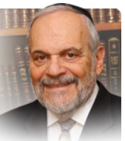

The Torah now proceeds from the general and universal story of humankind to concentrate on the particular and individual story of the founding of the Jewish people. The story of Avraham and Sarah, their difficulties and challenges, their loneliness and spiritual quest, form the essence of this parsha and the next one as well. In this life story they create the prototype for all later Jewish and familial society.

The Torah, unlike many more pious modern books of today, avoids painting for us a blissful picture of righteous people being blessed with serenity and perfection of character and behavior. Rather, it shows us the ever-present challenges to faith in the Almighty, the difficulties of maintaining domestic harmony and of creating a positive worldview while surrounded by enemies, jealousy and an immoral general culture.

Tradition and the Mishna crown Avraham with the laurel of having withstood and overcome ten major challenges in his lifetime. It is interesting that the great Jewish commentators to the Torah differ as to which ten challenges the Mishna is referring to. Thus, if we combine all of their opinions, there are a significantly greater number of challenges in the life of Avraham than just ten.

The Torah’s portrayal of these events – the wandering and rootlessness of coming to the promised land of Israel, the disloyalty of Lot, the difficulties with Sarah and Hagar, the behavior of Pharaoh and his courtiers, to mention some of them – all portray for us a life of struggle, of pain, of striving and of hurdles to overcome.

In spite of all of these very troubling details and incidents as recorded for us in the parsha, there is a tenor and tone of optimism and fulfilled purpose that permeates the entire parsha.  Even the cursory reader senses that Avraham and Sarah are up to something great – that this is no ordinary tale of pioneering and struggle. There are Godly covenants and blessings, commitments made that surely will be met and a vision presented of a great and influential people and of a holy land.

G-d’s relationship with humankind generally will be centered in His relationship to the family and progeny of Avraham and Sarah. Nations and beliefs will vie for the honor of being the descendants and followers of Avraham. Millions will adopt his name and follow his monotheistic creed. He and Sarah will be some of the most influential personages in world history. They will not avoid trouble and travail in their personal and family lives but great will be their reward in spiritual and historical achievement.

As such, they truly are the forerunners of the story of the Jewish people – a small and lonely people, wanderers and beset by inner disloyalty and external persecution – which nevertheless is optimistic and vastly influential in a manner that belies its physical numbers and temporal power.

Generally, Avraham is the father of many nations and of all monotheistic believers. But particularly he is the founder and father of the Jewish people whose march through human history parallels the life of Avraham itself. And, the G-dly covenant and blessings will assuredly be fulfilled through the accomplishments of the Jewish people, its nationhood and land.

*Reprinted from the current website of rabbiwein.com*